**Project Report**

**Course Title : Database Systems, Course Code : CSE 211, Section : C**

**Topic Name : Bangladeshi Student’s Abroad Database Management System**

**List of Members :**

|  |  |
| --- | --- |
| Name | Registration No |
| Md. Mujahid Hasan | 21201126 |
| Suriya Islam Afrin | 21201139 |
| Nazneen Nahar | 21201145 |
| Md. Arafat Kabir | 21201146 |
| Nishat Tasnim | 21201149 |

**“Bangladeshi Scholar’s Abroad Database Management System”**

**Description:** A government institution in Bangladesh is seeking data related to all students who have studied or studying abroad from their country, along with details about their educational journeys. Their primary focus is on students. Each Student has a unique student ID, and we maintain records of their personal information, such as their full name, gender, address, email, phone number, and passport ID. We track our students' progress in their academic programs. Each student can have multiple Academic Profiles, which include details like the study program name, the year of accomplishment of that study program, and their grade or credit earned on that program of study. Some of their students do Abroad Journey for educational purposes. We keep track of the start year and end year for each journey. Many students can travel abroad in the same year and come back to their home country in the same year. Many journeys can be done to a specific Country; they need details about these countries, like a unique country name and their official language, currency, and time zone. A student may receive multiple Scholarships to go abroad and may not receive any scholarship, and we maintain records of these awards. Each scholarship is assigned a unique scholarship ID and has a corresponding scholarship name. A foreign educational institution can offer various scholarships, and after getting one or many scholarships, their students get admitted to Foreign Institutions for further higher studies. We gather information about these institutions, including a unique institution ID, institution name, program of study, and admission year. Furthermore, many foreign institutions are connected to a specific Country. Many of their students often take various International Exams, and they need records of their exam results. Each exam is identified by a unique exam ID and includes information such as the exam name, exam year, and score. They also need tabs on their students' involvement in Extracurricular activities. Some students can have one or more extracurricular activities, and an activity can be associated with many students. Each activity has a unique activity ID and a name describing the activity.

**List of entities and their relationships:**

**Entities:**

1. **Student**

* Student ID (PK)
* Full Name
* Gender
* Address
* Email
* Passport ID

1. **Academic Profile**

* Program Name (PK)
* Year Accomplished
* Grade/Credit Earned

1. **Abroad Journey**

* Journey ID (PK)
* Start Year
* End Year

1. **Scholarship**

* Scholarship ID (PK)
* Scholarship Name

1. **Abroad Journey**

* Start Year
* End Year

1. **Foreign Institution**

* Institution ID (PK)
* Institution Name
* Program of Study
* Admission Year

1. **Country**

* Country Name (PK)
* Official Language
* Currency
* Time Zone

1. **International Exam**

* Exam ID (PK)
* Exam Name
* Exam Year
* Score

1. **Extra-Curricular Activity**

* Activity ID (PK)
* Activity Name

**Relationships:**

**One-to-Many Relationship: Student to Academic Profile**

* A student can have multiple academic profiles.

**One-to-Many Relationship: Student to Scholarship**

* A student can have multiple scholarships.

**Many-to-One Relationship: Scholarship to Foreign Institution**

* Many scholarships are associated with a specific foreign institution.

**Many-to-One Relationship: Foreign Institution to Country**

* Many foreign institutions are connected to a specific country. (Total Participation Double Line)

**Many-to-Many Relationship: Student to Abroad Journey**

* Many students can be associated with many abroad journey.

**Many-to-One Relationship: Abroad Journey to Country**

* Many journey can be done to one country.

**Many-to-Many Relationship: Student to International Exam**

* A student can take multiple international exams, and each exam can be taken by multiple students. We will create a new table of primary keys to represent this relationship.

**Many-to-Many Relationship: Student to Extra-Curricular Activity**

* A student can be involved in one or more extracurricular activities, and an activity can involve many students. We will create a new table of primary keys to represent this relationship.

Gives

Achieves

**ER Diagram:**

**International Exam**

Exam ID

Exam Name

Exam Year

Score

**Extra-curricular**

Activity ID

Activity Name

**Student**

Student ID

Full Name

Address

Email

Passport Id

Gender

**Country**

Country Name

Official Language

Currency

Time Zone

Sch_Edu

**Scholarship**

Scholarship ID

Scholarship Name

**Foreign Educational Institution**

Institution ID

Institution Name

Program of Study

Admission Year

Stu_Sch

**Current Academic Profile**

Program Name

Year Accomplished

Grade/Credit Earned

Stu_Aca

Departure

**Abroad Journey**

Start Year

End Year

Cou_Jou

Cou_Edu

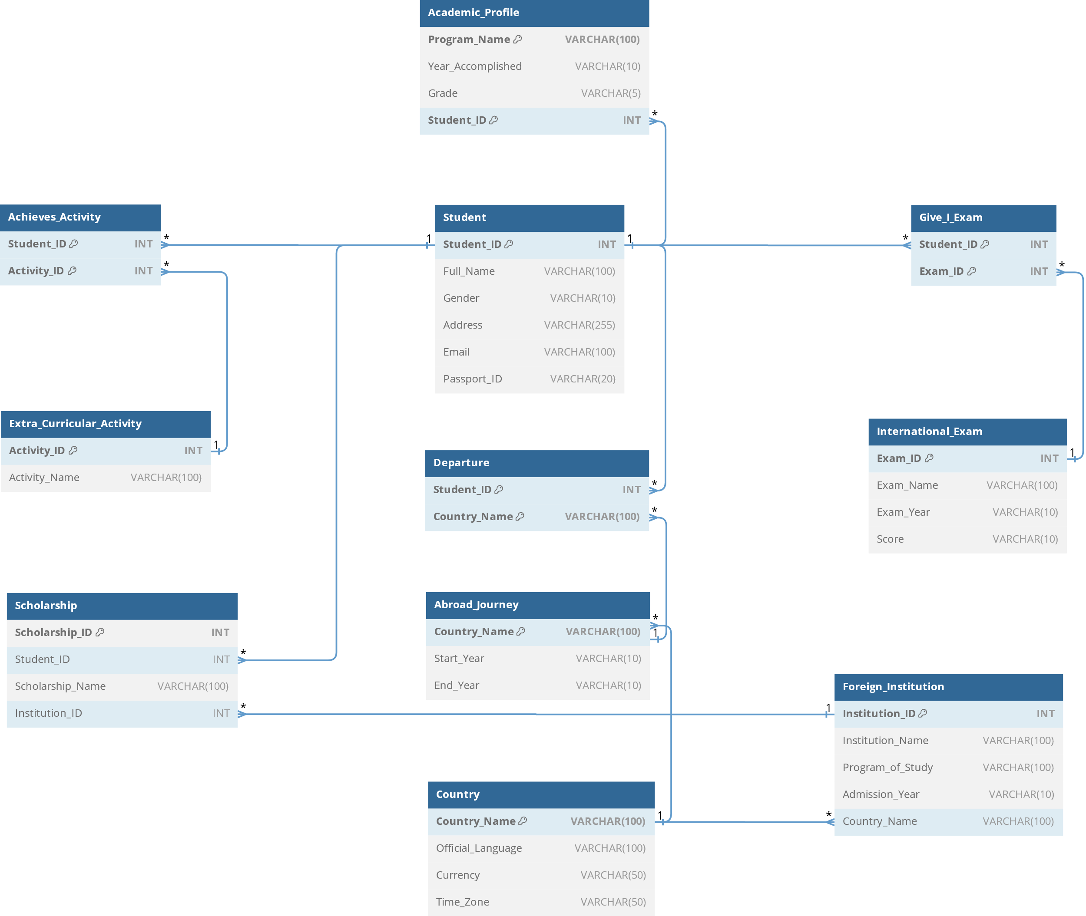

**Schema Diagram:**

-- Create the database

**SQL Code:**

USE master;

GO

IF EXISTS (SELECT name FROM master.dbo.sysdatabases WHERE name = N'Bangladeshi_Scholars_Abroad')

DROP DATABASE Bangladeshi_Scholars_Abroad;

CREATE DATABASE Bangladeshi_Scholars_Abroad;

GO

-- Use the database

USE Bangladeshi_Scholars_Abroad; USE master;

GO

-- Create the Student table

CREATE TABLE Student (

Student_ID INT PRIMARY KEY,

Full_Name VARCHAR(100),

Gender VARCHAR(10),

Address VARCHAR(255),

Email VARCHAR(100),

Passport_ID VARCHAR(20)

);

GO

-- Create the Academic Profile table

CREATE TABLE Academic_Profile (

Program_Name VARCHAR(100),

Year_Accomplished VARCHAR(10),

Grade VARCHAR(5),

Student_ID INT,

CONSTRAINT PK_Academic_Profile PRIMARY KEY (Program_Name, Student_ID),

CONSTRAINT FK_Student_AcademicProfile FOREIGN KEY (Student_ID) REFERENCES Student(Student_ID)

);

GO

-- Create the Extra-Curricular Activity table

CREATE TABLE Extra_Curricular_Activity (

Activity_ID INT PRIMARY KEY,

Activity_Name VARCHAR(100)

);

GO

-- Create the Achieves_Activity table (Many-to-Many Relationship)

CREATE TABLE Achieves_Activity (

Student_ID INT,

Activity_ID INT,

CONSTRAINT PK_Achieves PRIMARY KEY (Student_ID, Activity_ID),

CONSTRAINT FK_Student_Achieves FOREIGN KEY (Student_ID) REFERENCES Student (Student_ID),

CONSTRAINT FK_Activity_Achieves FOREIGN KEY (Activity_ID) REFERENCES

Extra_Curricular_Activity(Activity_ID)

);

GO

-- Create the International Exam table

CREATE TABLE International_Exam (

Exam_ID INT PRIMARY KEY,

Exam_Name VARCHAR(100),

Exam_Year VARCHAR(10),

Score VARCHAR(10)

);

GO

-- Create the Give_I_Exam table (Many-to-Many Relationship)

CREATE TABLE Give_I_Exam (

Student_ID INT,

Exam_ID INT,

CONSTRAINT PK_GiveExam PRIMARY KEY (Student_ID, Exam_ID),

CONSTRAINT FK_Student_GiveIExam FOREIGN KEY (Student_ID) REFERENCES Student (Student_ID),

CONSTRAINT FK_Exam_GiveIExam FOREIGN KEY (Exam_ID) REFERENCES

International_Exam(Exam_ID)

);

GO

-- Create the Country table

CREATE TABLE Country (

Country_Name VARCHAR(100) PRIMARY KEY,

Official_Language VARCHAR(100),

Currency VARCHAR(50), Time_Zone VARCHAR(50)

);

GO

-- Create the Foreign Institution table

CREATE TABLE Foreign_Institution (

Institution_ID INT PRIMARY KEY,

Institution_Name VARCHAR(100),

Program_of_Study VARCHAR(100),

Admission_Year VARCHAR(10),

Country_Name VARCHAR(100),

CONSTRAINT FK_Country_ForeignInstitution FOREIGN KEY (Country_Name) REFERENCES Country(Country_Name)

);

GO

-- Create the Scholarship table

CREATE TABLE Scholarship (

Scholarship_ID INT PRIMARY KEY,

Student_ID INT,

Scholarship_Name VARCHAR(100),

Institution_ID INT,

CONSTRAINT FK_Student_Scholarship FOREIGN KEY (Student_ID) REFERENCES Student (Student_ID),

CONSTRAINT FK_Institution_Scholarship FOREIGN KEY (Institution_ID) REFERENCES Foreign_Institution(Institution_ID)

);

GO

-- Create the Abroad Journey table

CREATE TABLE Abroad_Journey (

Country_Name VARCHAR(100) PRIMARY KEY,

Start_Year VARCHAR(10),

End_Year VARCHAR(10),

CONSTRAINT FK_Country_AbroadJourney FOREIGN KEY (Country_Name) REFERENCES Country(Country_Name)

);

GO

-- Create the Departure table

CREATE TABLE Departure (

Student_ID INT,

Country_Name VARCHAR(100),

CONSTRAINT PK_Departure PRIMARY KEY (Student_ID, Country_Name),

CONSTRAINT FK_Student_Departure FOREIGN KEY (Student_ID) REFERENCES Student (Student_ID),

CONSTRAINT FK_Country_Departure FOREIGN KEY (Country_Name) REFERENCES Country (Country_Name)

);

GO

-- Insert data into Student table

INSERT INTO Student (Student_ID, Full_Name, Gender, Address, Email, Passport_ID) VALUES

(1, 'Md Arafat Kabir', 'Male', '123 Gulshan Avenue, Dhaka', 'arafat@email.com', 'AB123456'),

(2, 'Nishat Tasnim', 'Female', '763 Station Road, Sylhet', 'nishat@email.com', 'CD789012'),

(3, 'Nazneen Nahar', 'Female', '011 GHI Avenue, Comilla', 'nazneen.nahar@email.com', 'EF345678'),

(4, 'Suriya Islam Afrin', 'Female', '101 Pine St, City4', 'suriya.afrin@email.com', 'GH901234'),

(5, 'Mujahid Hasan', 'Male', '768 Duramari, Thakurgaon', 'hasanmujahid@email.com', 'IJ567890'),

(6, 'Mehedi Hasan', 'Male', '12 Hazipara, Sirajganj', 'mehedi238@email.com', 'KL123456'),

(7, 'Foysal Hossain', 'Male', '54 Nabinagar Savar, Dhaka', 'foysal.hossain@email.com', 'MN234567'),

(8, 'Soma Das', 'Female', '234 MNO Lane, Narayanganj', 'das.soma@email.com', 'OP345678'),

(9, 'Sheikh Muhammad Ashik', 'Male', '393 Agrabad C/A, Chittagong', 'muhammadashik2@email.com', 'QR456789'),

(10, 'Naimul Islam', 'Male', '686 Khilgaon, Dhaka', 'naimul@email.com', 'ST567890');

-- Insert data into Academic_Profile table

INSERT INTO Academic_Profile (Program_Name, Year_Accomplished, Grade, Student_ID)

VALUES

('SSC', '2017', 'A+', 1),

('HSC', '2019', 'A+', 1),

('BSC', '2023', 'A+', 1),

('BSC', '2022', 'A+', 2),

('MSC', '2019', 'A+', 3),

('SSC', '2021', 'A', 4),

('BSC', '2020', 'B+', 5),

('HSC', '2022', 'A', 6),

('BSC', '2018', 'C+', 7),

('MSC', '2021', 'B', 8),

('BSC', '2021', 'B', 9),

('BSC', '2018', 'B', 10);

-- Insert data into Extra_Curricular_Activity table

INSERT INTO Extra_Curricular_Activity (Activity_ID, Activity_Name)

VALUES

(1, 'Drama Club'),

(2, 'Poetry Club'),

(3, 'Research Club'),

(4, 'Debate Team'),

(5, 'Math Club'),

(6, 'Drama Club'),

(7, 'Environmental Club'),

(8, 'Music Band'),

(9, 'Sports Team - Basketball'),

(10, 'Student Council');

-- Insert data into Achieves_Activity table

INSERT INTO Achieves_Activity (Student_ID, Activity_ID)

VALUES

(1, 1),

(2, 2),

(2, 4),

(2, 5),

(3, 6),

(4, 7),

(4, 8),

(4, 9),

(5, 10),

(6, 1),

(6, 2),

(7, 3),

(7, 4),

(8, 5),

(8, 6),

(9, 7),

(9, 8),

(9, 9),

(10, 10);

-- Insert data into International_Exam table

INSERT INTO International_Exam (Exam_ID, Exam_Name, Exam_Year, Score)

VALUES

(1, 'TOEFL', '2022', '95.5'),

(2, 'IELTS', '2021', '7.5'),

(3, 'SAT', '2023', '1450'),

(4, 'GRE', '2022', '320'),

(5, 'GMAT', '2021', '680'),

(6, 'ACT', '2023', '28'),

(7, 'DELE', '2022', '85.0'),

(8, 'HSK', '2021', '200'),

(9, 'MCAT', '2021', '520'),

(10, 'PTE Academic', '2022', '79.5');

-- Insert data into Give_I_Exam table

INSERT INTO Give_I_Exam (Student_ID, Exam_ID)

VALUES

(1, 1),

(1, 2),

(2, 3),

(2, 4),

(3, 5),

(3, 6),

(4, 7),

(4, 8),

(6, 1),

(6, 2),

(7, 3),

(7, 4),

(8, 5),

(8, 6),

(10, 9),

(10, 10);

-- Insert data into Country table

INSERT INTO Country (Country_Name, Official_Language, Currency, Time_Zone) VALUES

('United States', 'English', 'USD', 'GMT-5'),

('United Kingdom', 'English', 'GBP', 'GMT+0'),

('Canada', 'English, French', 'CAD', 'GMT-4'),

('Australia', 'English', 'AUD', 'GMT+10'),

('Germany', 'German', 'EUR', 'GMT+1'),

('Japan', 'Japanese', 'JPY', 'GMT+9'),

('France', 'French', 'EUR', 'GMT+1'),

('Brazil', 'Portuguese', 'BRL', 'GMT-3'),

('China', 'Mandarin', 'CNY', 'GMT+8'),

('India', 'Hindi, English', 'INR', 'GMT+5.5');

-- Insert data into Foreign_Institution table

INSERT INTO Foreign_Institution (Institution_ID, Institution_Name,

Program_of_Study, Admission_Year, Country_Name)

VALUES

(1, 'Harvard University', 'Computer Science', '2020', 'United States'),

(2, 'University of Toronto', 'Business Administration', '2019', 'Canada'),

(3, 'University of Oxford', 'Physics', '2021', 'United Kingdom'),

(4, 'University of Sydney', 'Engineering', '2020', 'Australia'),

(5, 'Technical University of Munich', 'Mechanical Engineering', '2022', 'Germany'),

(6, 'University of Tokyo', 'Mathematics', '2018', 'Japan'),

(7, 'Sorbonne University', 'French Literature', '2019', 'France'),

(8, 'Peking University', 'Economics', '2021', 'China'),

(9, 'Indian Institute of Technology Delhi', 'Computer Engineering', '2020', 'India'),

(10, 'University of São Paulo', 'Medicine', '2017', 'Brazil');

-- Insert data into Scholarship table

INSERT INTO Scholarship (Scholarship_ID, Student_ID, Scholarship_Name, Institution_ID)

VALUES

(1, 1, 'Merit Scholarship', 1),

(2, 2, 'Achievement Scholarship', 2),

(3, 3, 'Excellence Scholarship', 3),

(4, 4, 'Leadership Scholarship', 4),

(5, 5, 'Innovation Scholarship', 5),

(6, 6, 'Diversity Scholarship', 6),

(7, 7, 'Community Service Scholarship', 7),

(8, 8, 'Research Scholarship', 8),

(9, 9, 'Sports Scholarship', 9),

(10, 10, 'Need-Based Scholarship', 10);

-- Insert data into Abroad Journey table

INSERT INTO Abroad_Journey (Country_Name, Start_Year, End_Year)

VALUES

('United States', '2023', '2029'),

('Canada', '2023', '2028'),

('United Kingdom', '2022', '2027'),

('Australia', '2022', '2027'),

('Germany', '2023', '2028'),

('Japan', '2023', '2027'),

('France', '2019', '2022'),

('China', '2023', '2026'),

('India', '2021', '2026'),

('Brazil', '2018', '2022');

-- Insert data into Departure table

INSERT INTO Departure (Student_ID, Country_Name)

VALUES

(1, 'United States'),

(2, 'Canada'),

(3, 'United Kingdom'),

(4, 'Australia'),

(5, 'Germany'),

(6, 'Japan'),

(7, 'France'),

(8, 'China'),

(9, 'India'),

(10, 'Brazil');

-- Select data from the Student table

SELECT * FROM Student;

-- Select data from the Academic_Profile table

SELECT * FROM Academic_Profile;

-- Select data from the Extra_Curricular_Activity table

SELECT * FROM Extra_Curricular_Activity;

-- Select data from the Achieves_Activity table

SELECT * FROM Achieves_Activity;

-- Select data from the International_Exam table

SELECT * FROM International_Exam;

-- Select data from the Give_I_Exam table

SELECT * FROM Give_I_Exam;

-- Select data from the Country table

SELECT * FROM Country;

-- Select data from the Foreign_Institution table

SELECT * FROM Foreign_Institution;

-- Select data from the Scholarship table

SELECT * FROM Scholarship;

-- Select data from the Abroad_Journey table

SELECT * FROM Abroad_Journey;

-- Select data from the Departure table

SELECT * FROM Departure;

**SQL Code Link :** [Bangladeshi Scholar's Abroad - Google Drive](https://drive.google.com/file/d/1Jiln1ES_mfE0wtLCYThwsjUbl6-zbonk/view)

**Query Question :**

-- 1. Retrieve the full list of students.

SELECT *

FROM Student;

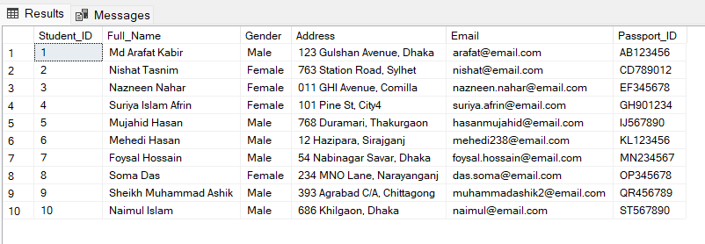

-- 2. Count the total number of students in the "Student" table.

SELECT COUNT(*) AS Total_Students

FROM Student;

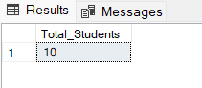

-- 3. Retrieve all the female students whose full names start with the letter 'N'.

SELECT *

FROM Student

WHERE Full_name LIKE 'N%' AND Gender = 'Female';

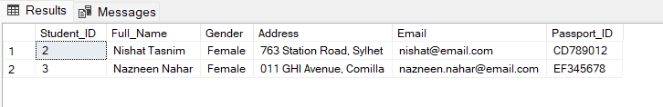

-- 4. Retrieve a list of distinct scholarship names from the Scholarship table, sorted in alphabetical order.

SELECT DISTINCT Scholarship_name

FROM Scholarship

ORDER BY Scholarship_Name;

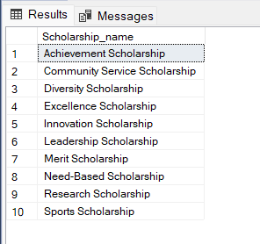

-- 5. Count the number of students who received scholarships.

SELECT COUNT(DISTINCT Student_ID) AS Scholarship_Count

FROM Scholarship;

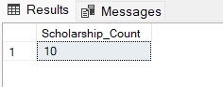

-- 6. Retrieve the Student IDs and Full Names of students who have achieved multiple activities.

SELECT Student_ID, Full_Name

FROM Student

WHERE Student_ID IN

(

SELECT Student_ID

FROM Achieves_Activity

GROUP BY Student_ID

HAVING COUNT(*) > 1

);

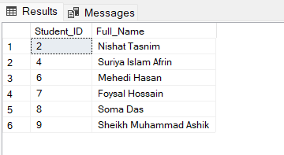

-- 7. Select the students who went to abroad without participating in any international exam.

SELECT * FROM Student

WHERE Student_ID NOT IN (SELECT Student_ID FROM Give_I_Exam);

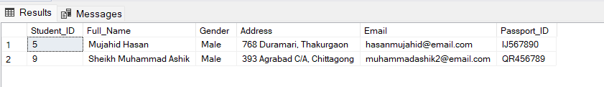

-- 8. Find the highest score among all students in international exams.

SELECT MAX(CAST(Score AS FLOAT)) AS Maximum_International_Exams_Score

FROM International_Exam;

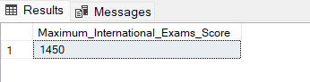

-- 9. Retrieve the information of students who have either a scholarship or have taken an international exam.

SELECT *

FROM Student

WHERE Student_ID IN (SELECT Student_ID FROM Scholarship)

OR Student_ID IN (SELECT Student_ID FROM Give_I_Exam);

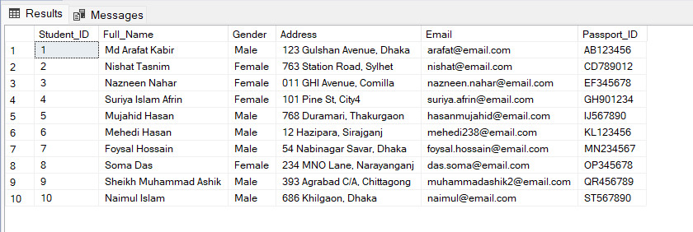

-- 10. Retrieve the students who got into Harvard University

SELECT Student_ID, Full_Name

FROM Student

WHERE Student_ID IN (

SELECT Student_ID

FROM Scholarship

WHERE Institution_ID = (

SELECT Institution_ID

FROM Foreign_Institution

WHERE Institution_Name = 'Harvard University'

)

);

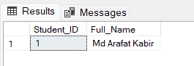

--- 11. Retrieve a list of all countries from the Country table, ordered in descending alphabetical order by country name.

SELECT *

FROM Country

ORDER BY Country_Name DESC;

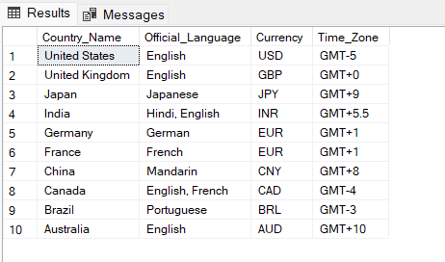

-- 12. Count and list the number of abroad journeys that started each year.

SELECT start_year, COUNT(*) AS year_statistics_count

FROM abroad_journey

GROUP BY start_year

ORDER BY start_year;

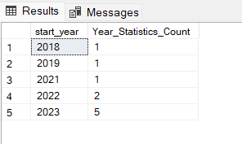

-- 13. Calculate the students average score for each exam type and show their information.

SELECT exam_name, AVG(CAST(score AS FLOAT)) AS average_score

FROM Student s

JOIN Give_I_Exam ge ON s.student_id = ge.student_id

JOIN International_Exam ie ON ge.exam_id = ie.exam_id

GROUP BY exam_name;

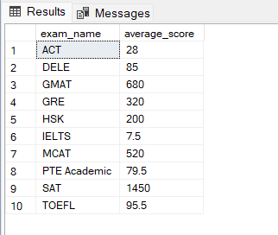

-- 14. List the academic programs that have the highest number of students who accomplished them.

SELECT ap.Program_Name, COUNT(*) AS Student_Count

FROM Academic_Profile ap

GROUP BY ap.Program_Name

ORDER BY Student_Count DESC;

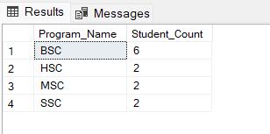

-- 15. List the student IDs and full names of students who have not traveled abroad.

SELECT Student_ID, Full_Name

FROM Student

WHERE Student_ID NOT IN (SELECT DISTINCT Student_ID FROM Abroad_Journey);

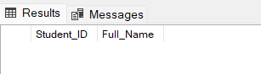

**CEP MAPPING**

**Knowledge Profile (K’s) addressed through our project and mapping among K’s, CO (Course Outcomes), PO (Program Outcomes):**

|  |  |  |  |  |
| --- | --- | --- | --- | --- |
| K’s | Attributes | How K’s are Addressed Through Our Project | CO | PO |
| K2 | Mathematics | Mathematics and statistics knowledge is necessary for various aspects of the project. This includes data analysis, ensuring data accuracy, and making informed decisions based on statistical information. Proficiency in mathematics and statistics is essential for effectively managing the database and scholarship data. | CO2, CO3, CO4 | PO1, PO3, PO5, PO6, PO7, PO8 |
| K3 | Engineering Fundamentals | In the context of the project, engineering fundamentals refer to a deep understanding of database fundamentals, which is essential for designing a suitable database model to manage information related to Bangladeshi students studying abroad. This knowledge ensures that the database is structured efficiently and securely. | CO2, CO3, CO4 | PO1 |
| K4 | Specialist Knowledge | Specialist knowledge pertains to expertise related to scholarship management. The project requires knowledge about how scholarships are managed, allocated, and tracked for Bangladeshi students studying abroad. This knowledge helps in implementing the scholarship component of the database system, ensuring it caters to the needs of stakeholders. | CO2, CO3, CO4 | PO1 |
| K5 | Engineering Design | Engineering design knowledge involves the use of ER (Entity-Relationship) diagrams and schema diagrams to design the database. These design elements are essential for organizing and structuring the database to efficiently store and retrieve information. Proper design contributes to the success of the project by ensuring data accuracy and accessibility. | CO3, CO4 | PO3, PO5 |
| K6 | Engineering Practice | Engineering practice refers to the practical implementation of the project using SQL in SQL Server Management Studio. This knowledge is necessary for creating and maintaining the database, ensuring data integrity, and optimizing performance. Implementing the project successfully relies on a strong grasp of SQL and database management practices. | CO1, CO2, CO5 | PO5 |
| K7 | Comprehension | Comprehension knowledge extends to understanding the positive societal impact achieved by facilitating access to education data. It involves recognizing the role the project plays in providing essential information about Bangladeshi students studying abroad. This knowledge ensures that the project aligns with its societal impact goals. | CO6, CO7 | PO6, PO7, PO8 |

**Complex Engineering Problems (P’s) addressed through our project and mapping among P’s, CO (Course Outcomes), PO (Program Outcomes):**

|  |  |  |  |  |
| --- | --- | --- | --- | --- |
| P’s | Attributes | How P’s are Addressed Through Our Project | CO | PO |
| P1 | Depth of Knowledge Required | The project addresses complex engineering problems by requiring in-depth knowledge in various areas, including database fundamentals, scholarship management, ER and schema diagrams, SQL implementation, and societal impact. These aspects are essential for solving the complex problems of efficiently managing information about students studying abroad. The successful resolution of these problems aligns with the project's core objectives. | CO1, CO2, CO3, CO4, CO5 | PO1, PO3, PO5, PO6, PO7, PO8 |
| P3 | Depth of Analysis Required | The project calls for further analysis to optimize integrity constraints and efficiency in managing the database. This analysis ensures that the database remains robust and that the information is accurate and accessible. These optimizations contribute to achieving the desired project outcomes. | CO3, CO4, CO5 | PO6, PO7, PO8, PO12 |
| P6 | Extent of Stakeholders | The project caters to the needs of multiple stakeholders, primarily Bangladeshi students studying abroad and the government institution seeking access to their data. These stakeholders have diverse requirements related to scholarship management, educational journeys, and academic profiles. Addressing these diverse needs aligns with complex engineering problems and helps achieve the project objectives. | CO6, CO7 | PO9, PO10 |
| P7 | Interdependence | To address complex problems efficiently, the project breaks down the database into smaller tables. This modular approach enables better problem-solving, as it allows for a more focused and systematic approach to data management. Breaking down the project into smaller components aligns with specific project objectives. | CO8 | PO11 |

**Complex Engineering Activities (A’s) addressed through our project and mapping among A’s, CO (Course Outcomes), PO (Program Outcomes):**

|  |  |  |  |  |
| --- | --- | --- | --- | --- |
| A’s | Attributes | How A’s are Addressed Through Our Project | CO | PO |
| A1 | Range of Resources | The project involves utilizing a diverse range of resources, including data, technologies, people, and financial investments, to build and maintain the database system. This comprehensive approach ensures that the project has the necessary resources to succeed and meet its objectives. The efficient utilization of these resources contributes to the project's success. | CO8 | PO11 |
| A4 | Consequences for Society and Environment | The project has positive consequences for society by improving the management of information related to Bangladeshi students studying abroad. It contributes to educational and societal development, as it enhances access to education data and scholarship information. This positive societal impact aligns with several project objectives. | CO6 | PO6, PO7, PO8 |
| A5 | Familiarity | One of the primary complex engineering activities of the project is the development of an online system for managing information related to Bangladeshi students studying abroad. This activity requires familiarity with database design and management practices, software development, and user interface design. Ensuring that the project team is familiar with these activities contributes to project success. | CO9 |  |